JUnit Advanced Testing Exercises

Name: Shubham Bej

Aim
To understand and implement advanced unit testing concepts using JUnit 5 (JUnit Jupiter), including parameterised tests, test suites, test execution order, exception testing, and performance testing in a Maven-based Java project.

Objectives
- To create parameterised test cases using JUnit 5.
- To group multiple test classes using test suites.
- To control the execution order of test methods.
- To verify exception handling using JUnit assertions.
- To measure execution time using timeout assertions.
- To gain practical experience with advanced JUnit testing techniques.

Software Requirements
- IntelliJ IDEA Community Edition
- Java JDK 21
- Apache Maven
- JUnit 5 (JUnit Jupiter)
- Git
- GitHub

Theory
JUnit 5 is the latest version of the JUnit testing framework for Java. It provides a flexible architecture and powerful annotations for writing maintainable and efficient unit tests. Compared to JUnit 4, it introduces improved support for parameterised testing, test suites, lifecycle management, and performance testing.

Features of JUnit 5
- Parameterised testing with multiple input values.
- Test suites for grouping related test classes.
- Ordered execution of test methods.
- Exception testing using, assertThrows().
- Performance testing using, assertTimeout().
- Seamless integration with Maven and IntelliJ IDEA.

Exercises Performed

Exercise 1 – Parameterised Tests

Description
A class named EvenChecker was created to determine whether a number is even. A parameterised test was written using the @ParameterizedTest and @ValueSource annotations to execute the same test with multiple input values.

Concepts Used
- @ParameterizedTest
- @ValueSource
- assertTrue()

Outcome
The method was tested with multiple even numbers, and all test cases passed successfully.
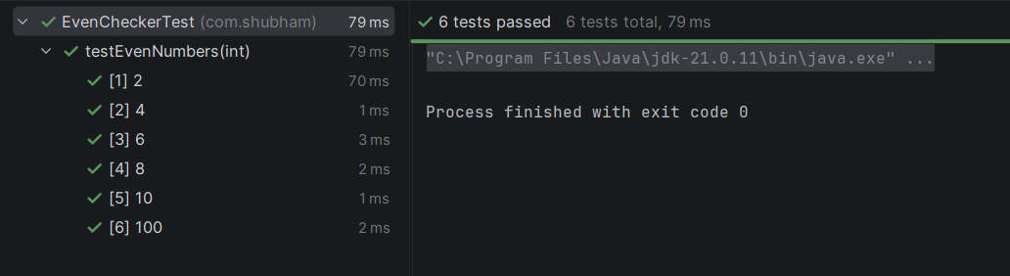

Exercise 2 – Test Suites

Description
A test suite named AllTests was created to execute multiple test classes together. The suite groups all test classes into a single execution using JUnit Suite annotations.

Concepts Used
- @Suite
- @SelectClasses

Outcome
All test classes executed successfully through a single suite.
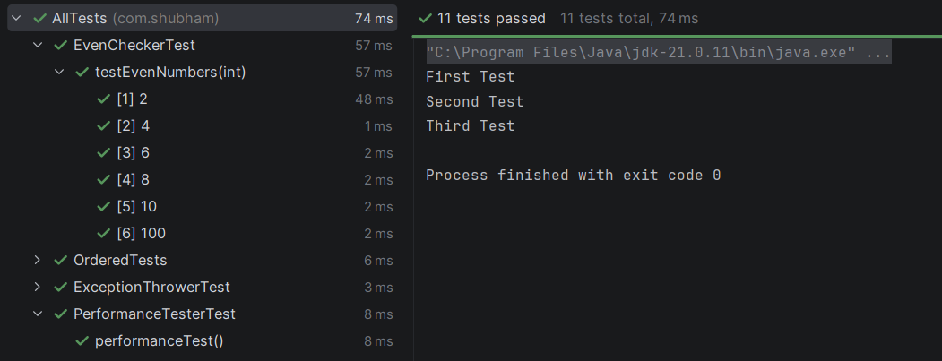

Exercise 3 – Test Execution Order

Description
A test class named OrderedTests was created to demonstrate controlled execution order. The methods were annotated with @Order and the class was configured using @TestMethodOrder.

Concepts Used
- @TestMethodOrder
- @Order

Outcome
The test methods executed sequentially in the specified order.
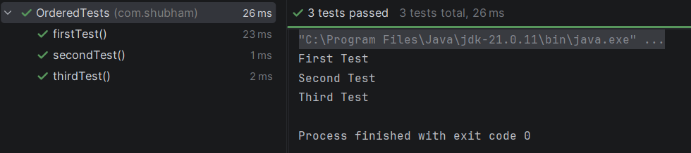

Exercise 4 – Exception Testing

Description
A class named ExceptionThrower was created to throw an exception intentionally. The test class verified the expected exception using JUnit's assertThrows() method.

Concepts Used
- assertThrows()

Outcome
The expected IllegalArgumentException was thrown and successfully validated.
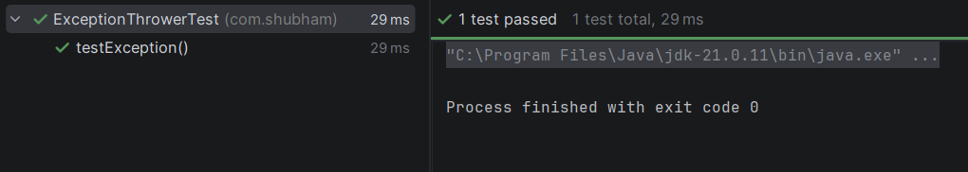

Exercise 5 – Timeout and Performance Testing

Description
A class named PerformanceTester was developed to execute a computational task. The test ensured that the method completed execution within a specified time limit using assertTimeout().

Concepts Used
- assertTimeout()
- Duration

Outcome
The task was completed within the specified timeout period, and the test passed successfully.
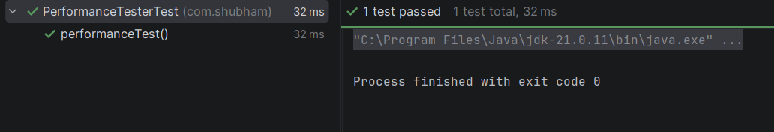

Project Structure
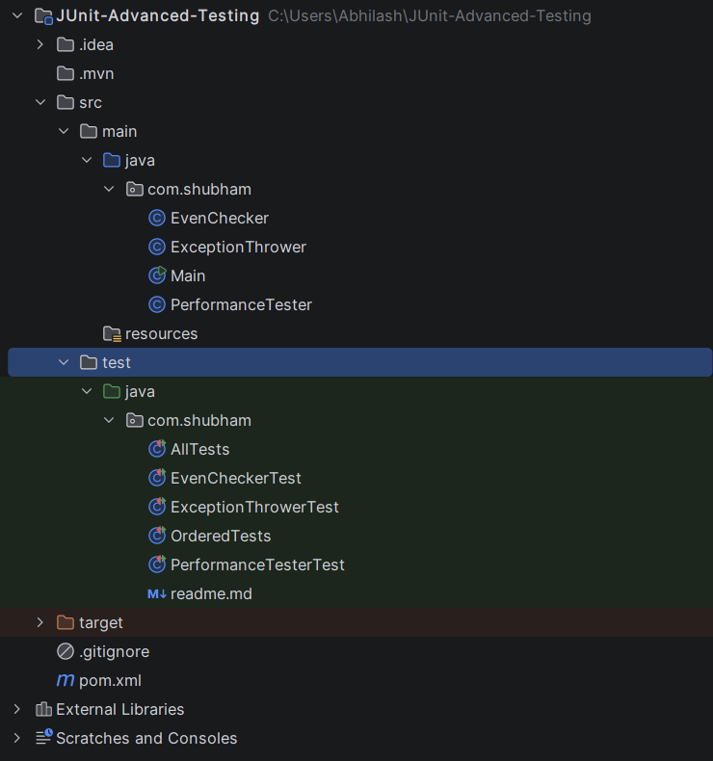

Results
The following advanced JUnit concepts were successfully implemented:
- Maven project creation with JUnit 5
- Parameterised testing
- Test suite creation
- Ordered execution of test methods
- Exception testing
- Timeout and performance testing
- Successful execution of all test cases

Advantages of JUnit 5
- Reduces manual testing effort.
- Supports reusable and maintainable test cases.
- Provides better code quality through automated testing.
- Simplifies exception and performance testing.
- Offers powerful annotations and modular architecture.
- Integrates seamlessly with modern Java development tools.

Conclusion
The experiment successfully demonstrated advanced testing capabilities using JUnit 5. Parameterized tests enabled efficient validation with multiple inputs, test suites simplified execution of multiple test classes, ordered execution ensured predictable test flow, exception testing verified error handling, and performance testing confirmed execution within the specified time limit. These features collectively improve software reliability, maintainability, and overall code quality.

References
- JUnit 5 User Guide – https://junit.org/junit5/docs/current/user-guide/
- Apache Maven Documentation – https://maven.apache.org/
- Oracle Java Documentation – https://docs.oracle.com/en/java/

Codes Used

pom.xml:
<?xml version="1.0" encoding="UTF-8"?>
<project xmlns="http://maven.apache.org/POM/4.0.0"
xmlns:xsi="http://www.w3.org/2001/XMLSchema-instance"
xsi:schemaLocation="http://maven.apache.org/POM/4.0.0
https://maven.apache.org/xsd/maven-4.0.0.xsd">
<modelVersion>4.0.0</modelVersion>
<groupId>com.shubham</groupId>
<artifactId>JUnit-Advanced-Testing</artifactId>
<version>1.0-SNAPSHOT</version>
<properties>
<maven.compiler.source>21</maven.compiler.source>
<maven.compiler.target>21</maven.compiler.target>
<project.build.sourceEncoding>UTF-8</project.build.sourceEncoding>
<junit.version>5.10.2</junit.version>
</properties>
<dependencies>
<!-- JUnit 5 -->
<dependency>
<groupId>org.junit.jupiter</groupId>
<artifactId>junit-jupiter</artifactId>
<version>${junit.version}</version>
<scope>test</scope>
</dependency>
<dependency>
<groupId>org.junit.jupiter</groupId>
<artifactId>junit-jupiter-params</artifactId>
<version>${junit.version}</version>
<scope>test</scope>
</dependency>
<dependency>
<groupId>org.junit.platform</groupId>
<artifactId>junit-platform-suite</artifactId>
<version>1.10.2</version>
<scope>test</scope>
</dependency>
</dependencies>
<build>
<plugins>
<plugin>
<groupId>org.apache.maven.plugins</groupId>
<artifactId>maven-surefire-plugin</artifactId>
<version>3.2.5</version>
</plugin>
</plugins>
</build>
</project>

EvenChecker.java:
package com.shubham;
public class EvenChecker {
public boolean isEven(int number) {
return number % 2 == 0;
}
}

ExceptionThrower.java:
package com.shubham;
public class ExceptionThrower {
public void throwException() {
throw new IllegalArgumentException("Exception Thrown");
}
}

PerfomanceTester.java:
package com.shubham;
public class PerformanceTester {
public void performTask() {
for(int i=0;i<1000000;i++){
Math.sqrt(i);
}
}
}

EvenCheckerTest.java:
package com.shubham;
import org.junit.jupiter.params.ParameterizedTest;
import org.junit.jupiter.params.provider.ValueSource;
import static org.junit.jupiter.api.Assertions.*;
public class EvenCheckerTest {
EvenChecker checker = new EvenChecker();
@ParameterizedTest
@ValueSource(ints = {2,4,6,8,10,100})
void testEvenNumbers(int number){
assertTrue(checker.isEven(number));
}
}

ExceptionThrowerTest.java:
package com.shubham;
import org.junit.jupiter.api.Test;
import static org.junit.jupiter.api.Assertions.*;
public class ExceptionThrowerTest {
ExceptionThrower exceptionThrower = new ExceptionThrower();
@Test
void testException(){
assertThrows(IllegalArgumentException.class,
() -> exceptionThrower.throwException());
}
}

OrderedTest.java:
package com.shubham;
import org.junit.jupiter.api.*;
@TestMethodOrder(MethodOrderer.OrderAnnotation.class)
public class OrderedTests {
@Test
@Order(1)
void firstTest(){
System.out.println("First Test");
}
@Test
@Order(2)
void secondTest(){
System.out.println("Second Test");
}
@Test
@Order(3)
void thirdTest(){
System.out.println("Third Test");
}
}

PerformanceTesterTest.java:
package com.shubham;
import org.junit.jupiter.api.Test;
import static org.junit.jupiter.api.Assertions.assertTimeout;
import java.time.Duration;
public class PerformanceTesterTest {
PerformanceTester tester = new PerformanceTester();
@Test
void performanceTest(){
assertTimeout(Duration.ofSeconds(2),
() -> tester.performTask());
}
}

AllTests.java:
package com.shubham;
import org.junit.platform.suite.api.SelectClasses;
import org.junit.platform.suite.api.Suite;
@Suite
@SelectClasses({
EvenCheckerTest.class,
OrderedTests.class,
ExceptionThrowerTest.class,
PerformanceTesterTest.class
})
public class AllTests {
}

